SAURIN NAYAK (ID 143022)

Demonstrate the following and write a technical report about it explaining each of the below tool. Screenshots can be used to demonstrate.
1. Project schedule
2. Baseline
3. Resource leveling
4. Critical Path
5. Project Milestone
6. Gantt Chart
7. EVM
8. CPI
9. SPI
10. Show how to set task dependencies
11. How to generate reports
I am demonstrating the software development life cycle phases as an example with Microsoft project.

- Project Schedule:
It is the listing of the desired deliverables and activities in any project. Here I put my activity sequence as tasks and given them the desired timeframes in which I am planning to finish. As shown in the screenshot, each task has duration shown in number of days and with start and end dates.
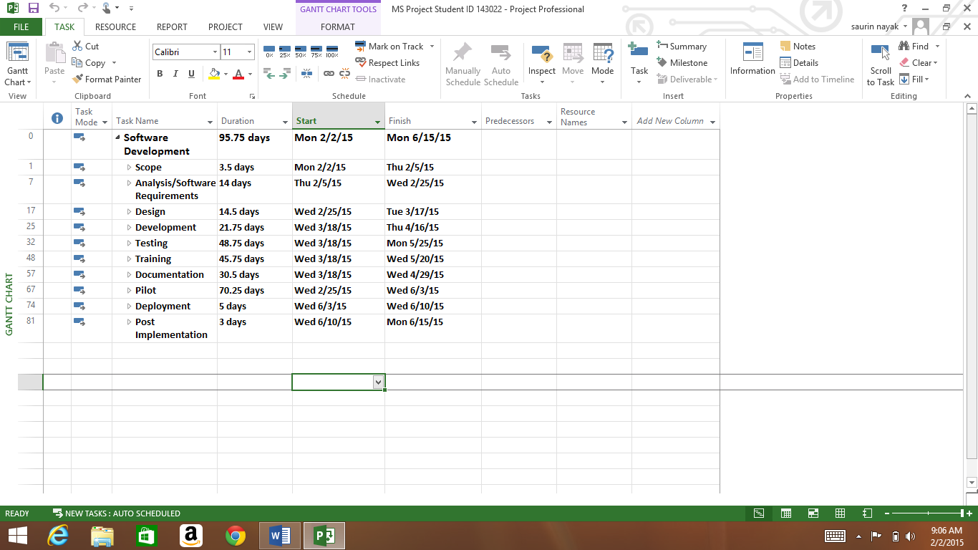
2. Baseline
In project management, baseline means a point of reference. It is a value or a condition against which all future measurements will be compared. I have added two screenshots here to demonstrate how the baseline works. In the first pic, I have used the normal gantt chart view with variance tables so that when I selected “set baseline” from view tab on the top, I can see the difference what the setting baseline made. It can be seen in the second screenshot.
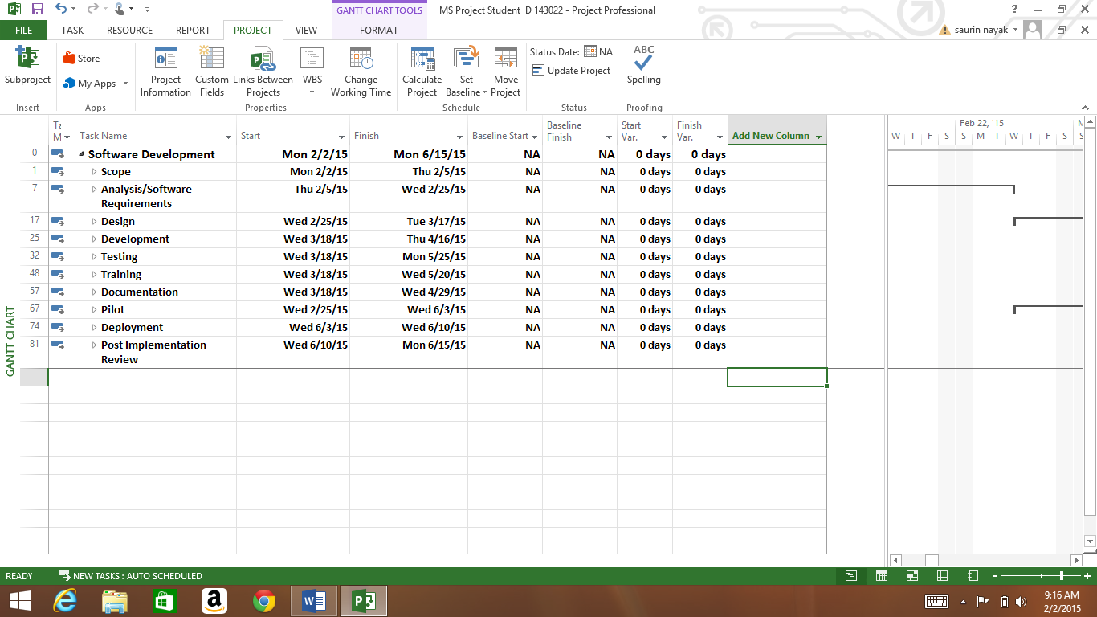
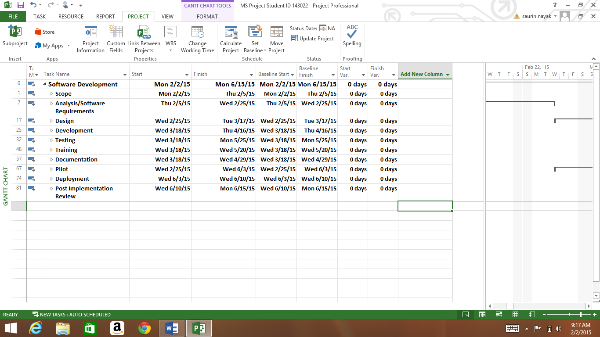

- Resource leveling
It is a technique in which start and finish dates are adjusted based on resource constraints with the goal of balancing demand for resources with the available supply. RESOURCE tab on the top allows us to use the functions of resource leveling, resource pool and assigning resources. In the VIEW tab selecting the view by leveling from Gantt chart view, we can see the leveling as below, it can be edays, eweeks etc.
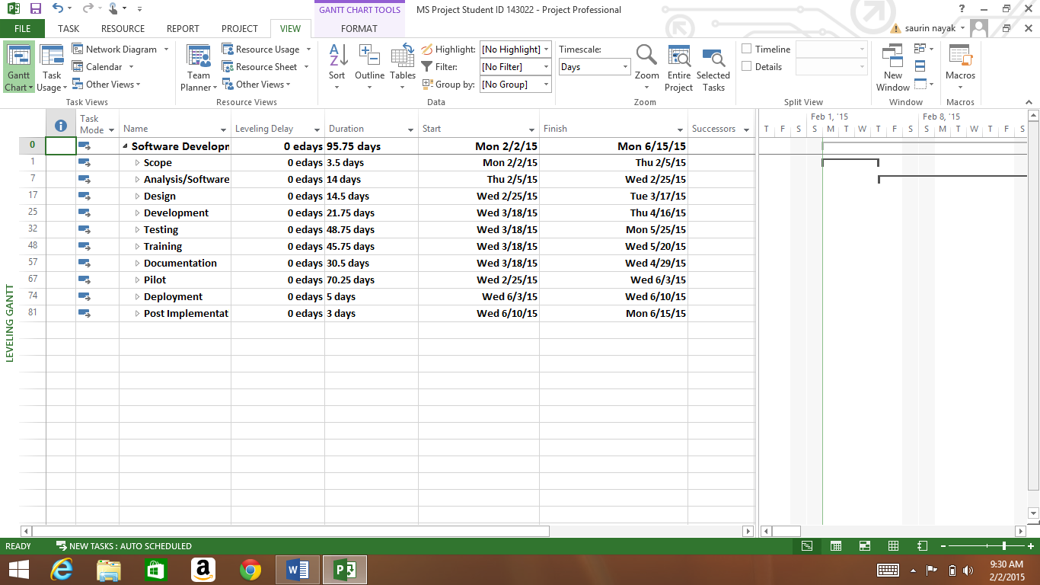
In the below screenshot, I have selected the resource tab from where we can assign the leveling by going in to the resource leveling, from leveling options.
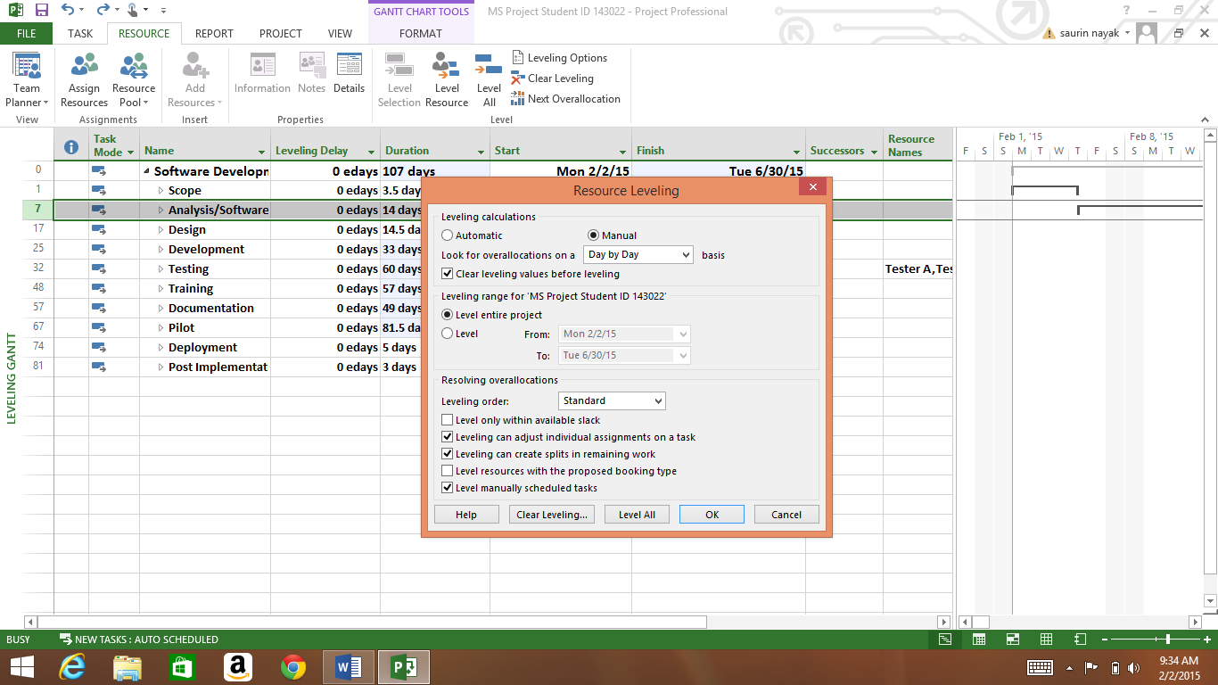

- Critical Path
It is the sequence of project network activities which add up to the longest overall duration. This determines the shortest time possible to complete the project.
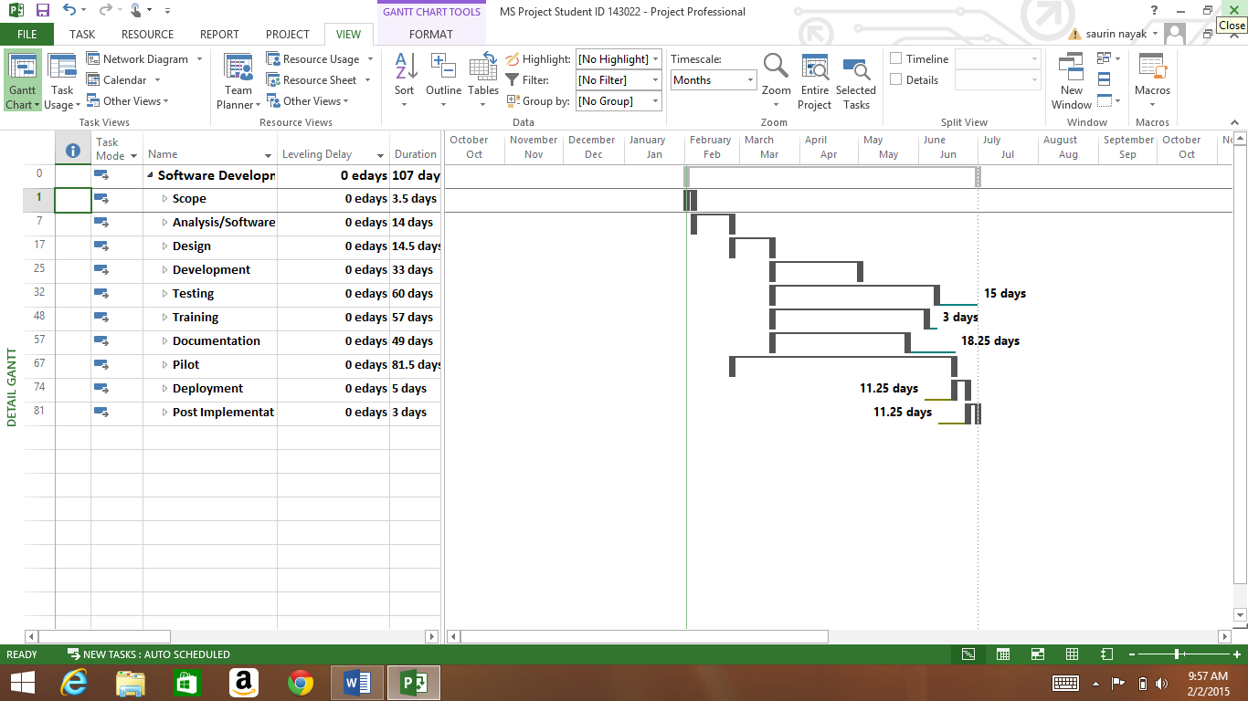
- Project Milestone
Milestones are a tool used in project management to mark specific points along a project timeline. These points may signal anchors such as project start and end date. In many instances, milestones do not impact project duration but they focus on major progress points that must be reached to achieve success towards desired plan. In the below screenshot, for my project I have selected the analysis completion and the post deployment as my milestones, which are shown in dark red diamond shape in the Gantt chart.

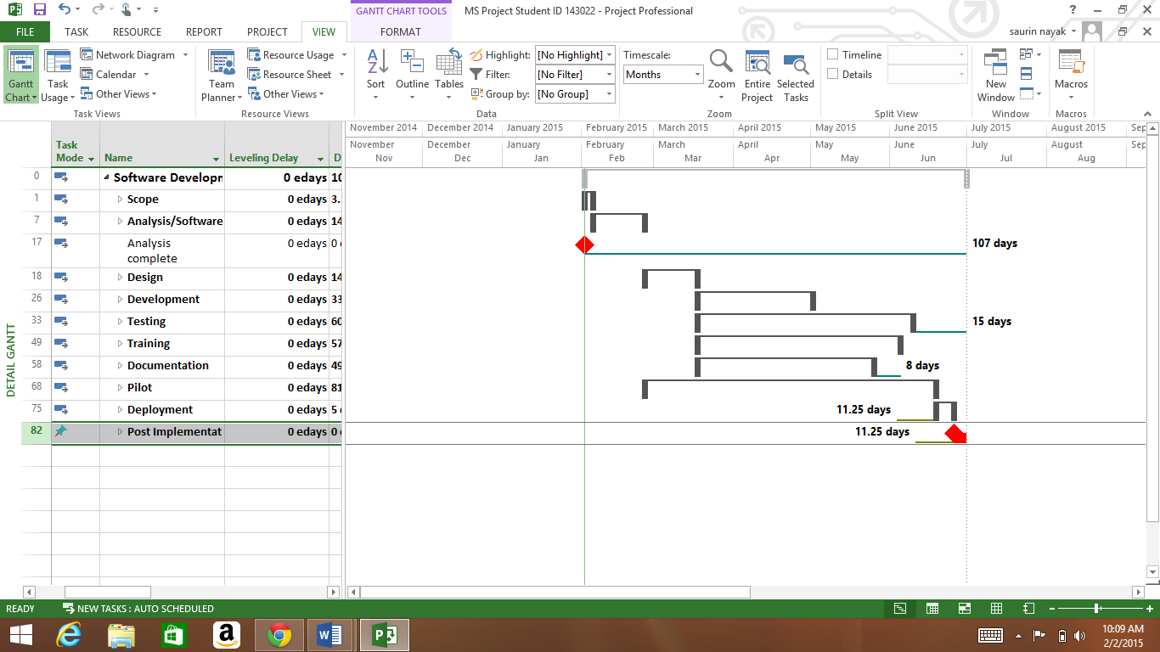
- Gantt Chart
It is one of the most popular and useful ways of showing activities, tasks or events against time.
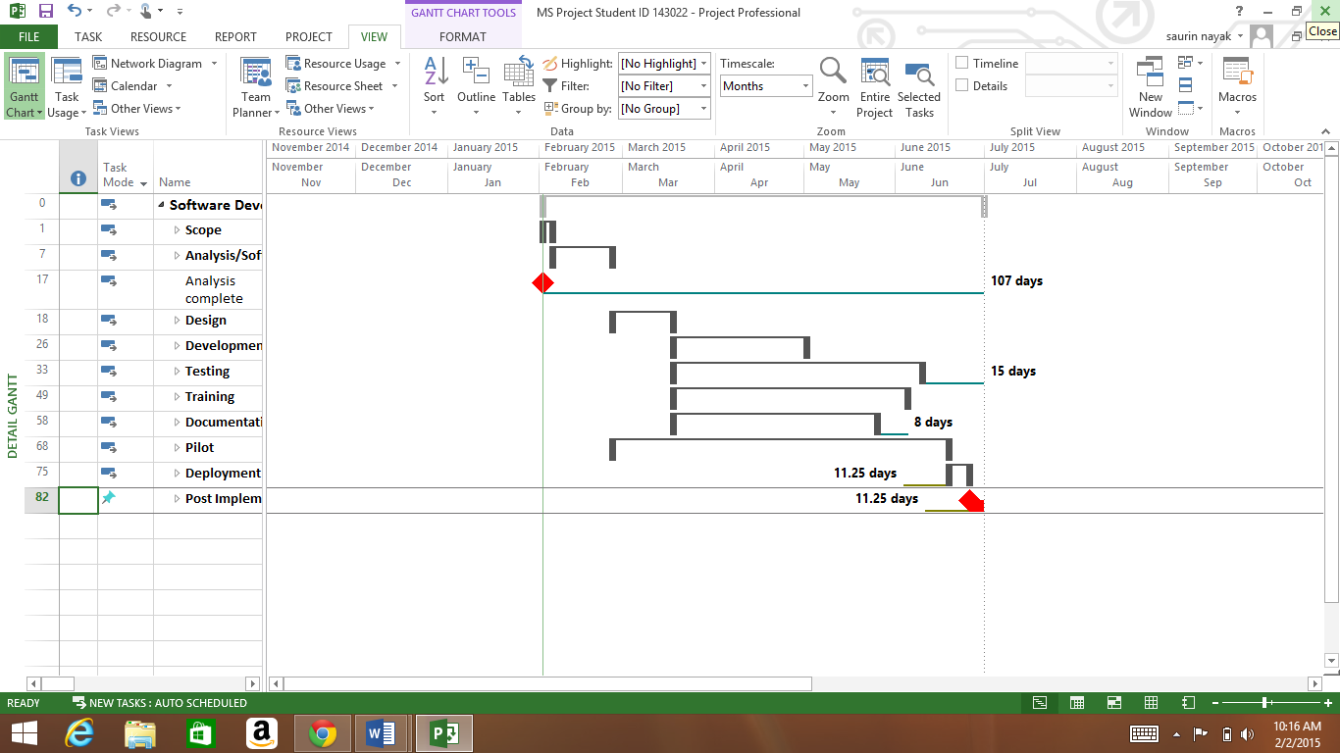

- EVM
EVM – earned value management is a project management technique for measuring project performance and progress. By clicking on the table views and selecting EVM there, it will show the below screen with the values. The values of cost and materials can be added using the resource management tool.
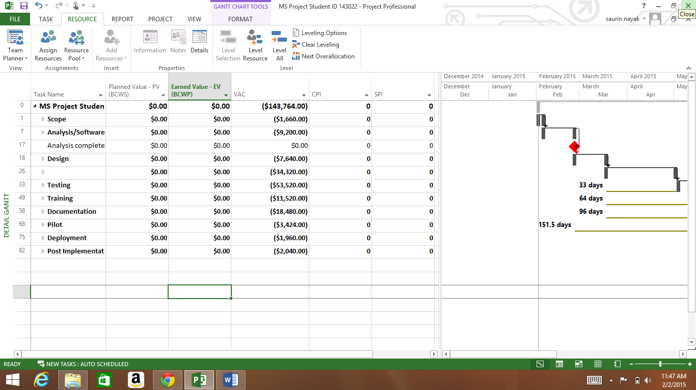
- CPI
Cost Performance Index is an indication of the cost performance of the project. It helps to analyze the efficiency of the cost utilized by the project. It informs that how much revenue has generated for each dollar spent on the project.
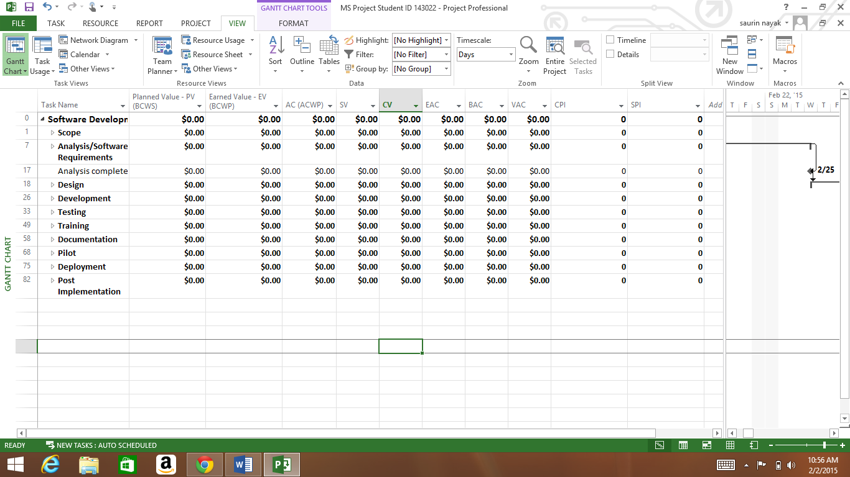
- SPI
Schedule Performance Index gives information about the schedule performance of the project. It informs about the efficiency of the actual performance compare to the planned progress.

- Show how to set task dependencies
In project management, after tasks are created, they need to be linked to show the relationship between them. In the picture below it has been shown with an arrow or a cursor. I had selected the tasks and linked those showing dependencies, as below:
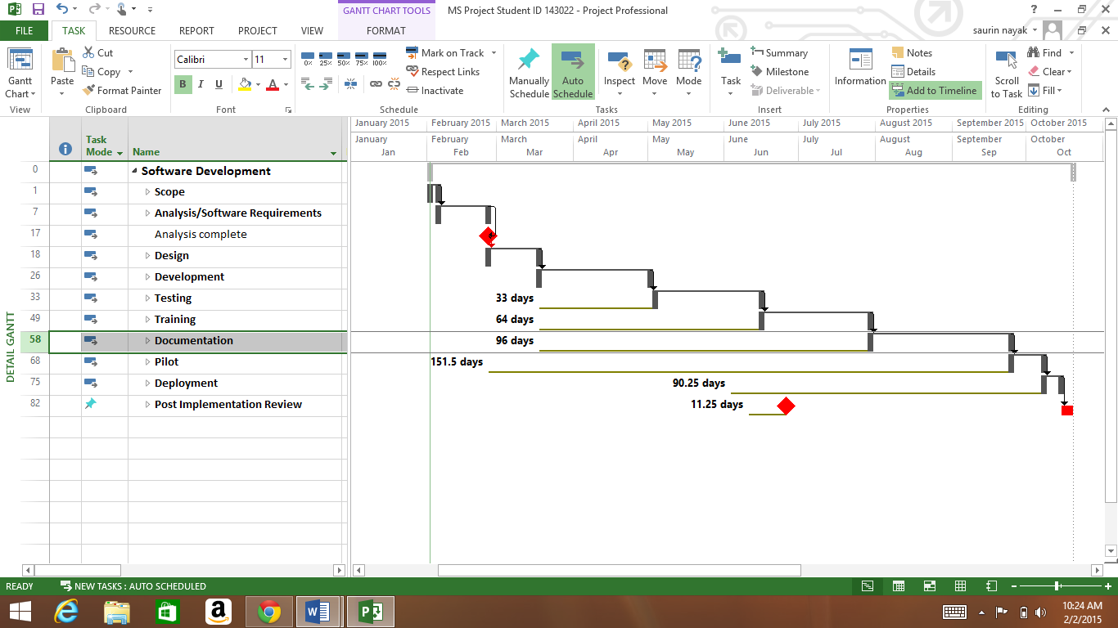
- How to generate reports
Reports allow looking across multiple sheets that show you only items that meets the criteria you have specified.
